**Wednesday, January 31st**

1. You'll learn basics like introducing yourself, making small talk, and discussing your work.

<https://www.freecodecamp.org/learn/a2-english-for-developers/>

Oral comprehension, vocabulary and structures, practice with role plays.

**1 A) Learn Greetings in your First Day at the Office**

In this first course, you'll learn common expressions for situations you may encounter on your first day at work. You'll learn about introductions, getting to know people, asking for lunch recommendations, and getting an access card from security.

**1 B) Learn Introductions in an Online Team Meeting**

In this course, you'll learn how to give a personal introduction. You'll also learn how to state your profession, and share your goals in group meetings.

**1C) Learn Conversation Starters in the Break Room**

In this course, you'll learn how to start a conversation in casual settings. You'll also learn how to talk about your hobbies and personality traits. You'll even learn how to ask about places around the town.

**Sentence A**: The new Software doesn’t fulfill our requirements.  
**Sentence B**: The new Software doesn’t have the things we need.

Technically, both sentences are grammatically correct, but "fulfill our requirements" is overly formal and awkward. It's more suited for a business document than an everyday conversation. Sentence B is simpler and closer to what a native speaker would say.

---

You’ve understood that, you don’t need to be a language expert to communicate in English, but be able to convey the right message.

In the second half (tomorrow), you'll practice vocabulary specific to software development, review the lesson and English basics, try to understand technical documentation and more!

English is the official language of software development. In this article, we’ll discuss real-world English for developers.

✓ Professional correspondence such as emails, memorandums, and formal letters

To demonstrate this, here is an example of an email from your project manager:

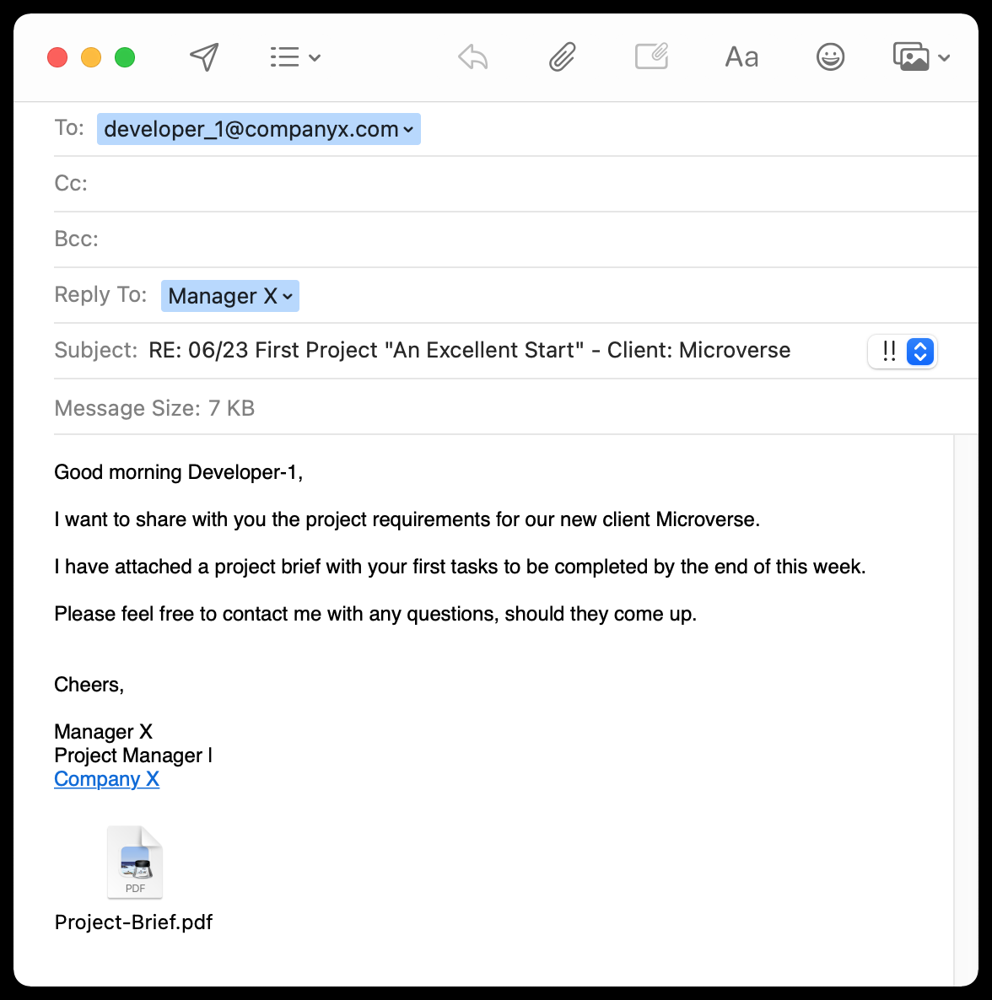

Photo by Steve W Dames Jr

A great professional email is short, clear, and allows the reader to visualize one idea.

Let’s have a look at the tips for writing effective professional emails.

Here they are:

## 1. Professional Email Title that Rings a Bell

Which one is better?

**Subject: Meeting notes**

Or

**Subject: RE: 11/23 – Database migration meeting –**[**Meeting Notes**](https://itpmschool.com/team-meetings/)

And you do see that the second one is a reply to the initial email on the meetings. With all the information relevant to the topic.

## 2. Address the Email Correctly

There are three address lines for email:

**To:**

I prefer to have only one email address in this field. It is the person I want to take action or have a response from.

In case you do need to ask several persons to take action, make it clear at once. Use a special character to draw attention, like “@” or bold the names.

However, I do recommend to keep it to the main rule:

One email, one responsible person, one action.

**Cc:**

Here, you can put everyone else who needs to be informed.

If you want people on this list to read your email, do select them carefully for each separate message. When you are in “Cc” for a long time, you start treating it as spam.

What do you do with spam?

Right. Ignore it.

**Bcc:**

Blind Carbon Copy gives you an opportunity to put a recipient that will not be shown in the email details.

It looks like a cool way to expose your correspondence with a third party or your boss.

There might be some legal and NDA cases when you need to Bcc someone, but you can always workaround it by forwarding the email thread.

Therefore, I would suggest limiting the [use of Bc](http://www.huffingtonpost.com/2012/01/22/email-etiquette-bcc_n_1221901.html)[c](https://www.huffpost.com/entry/email-etiquette-bcc_n_1221901) for the purpose of archiving your correspondence. It may go to a separate email account or your assistant.

## 3. Cut to the Chase in the First sentence

So, just after you write “Hi John” or “Dear John,” the very next sentence should state what you want or need.

Here is a bad example:

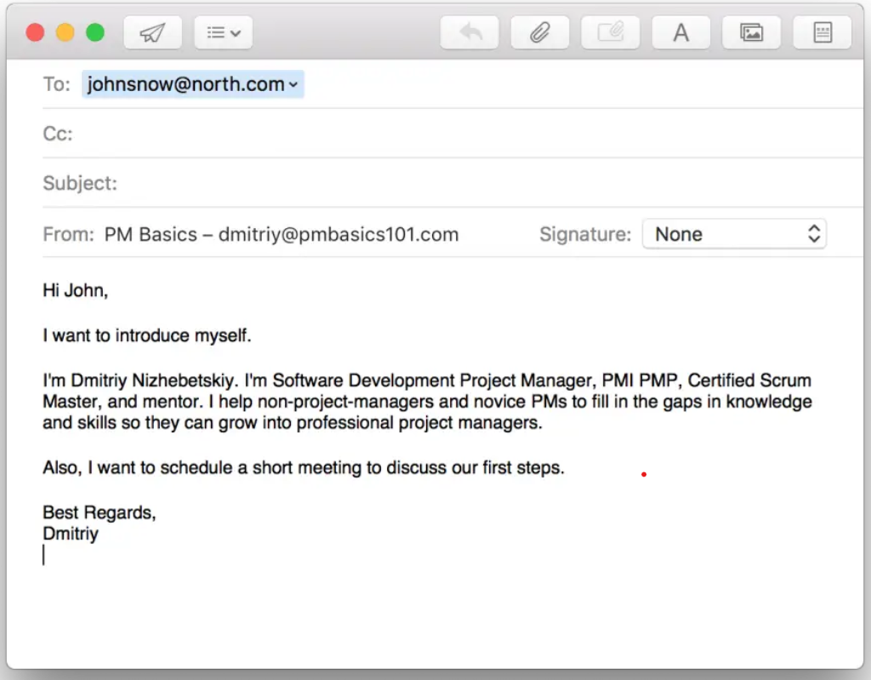

Here is a better one:

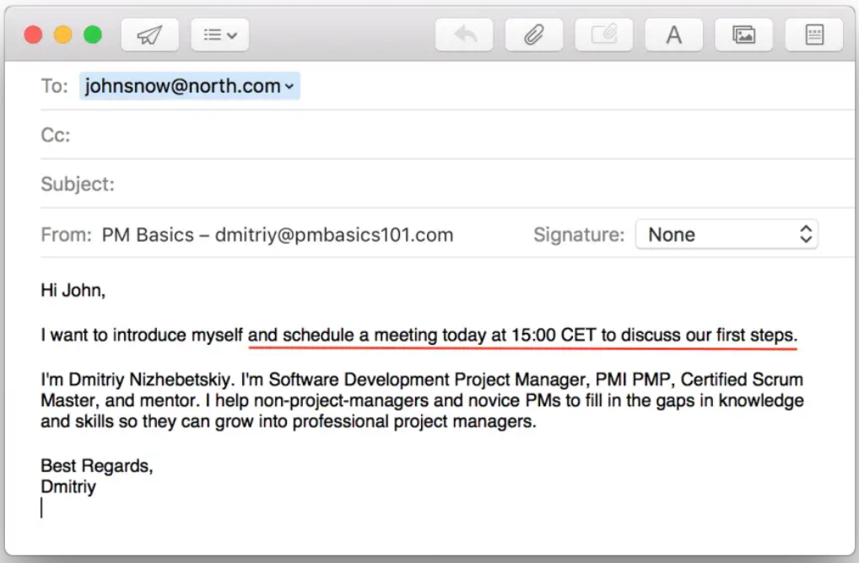

Still, it is not good enough.

Here is the catch:

## 4. Say What You Want With a Call to Action

It should clearly state what you expect from the person you write to.

So, in the previous example, I need a confirmation on the meeting.

I can end up with something like this:

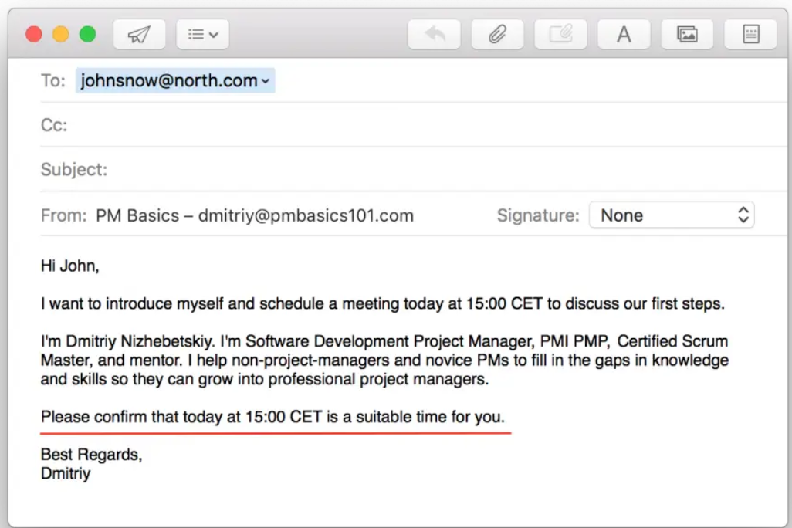

It may feel that some emails do not need a call to action. For example, when you provide a short answer or a document. In general, when you don’t need anything in return.

In fact, you may end up with the following CTAs:

* Please let me know if you have any other questions.
* Please let me know if this answers your questions.
* Feel free to contact me for any additional details.

This way, you remove a barrier for clarification. Such CTAs will save you from lots of miscommunications.

## 5. One Action per Email

There should only be one Call to Action per email.

Why?

A busy person sees several questions, and he or she must answer the email promptly. What is the easiest workaround? Right! Select a simple question and give a short answer.

## 6. Details in the middle

So, how does it work?

John can read the headline and the first sentence even without opening an email.

You do the same, don’t you?

If the headline and the entry phrase look important, you will open an email.

But do you read it carefully at once? No!

## 7. So, keep you email short. Shorter!

The whole email should be as brief as possible.

## 8. Do You Need a Signature?

The short answer is Yes.

Though there are some rules here.

* Don’t use images. Especially for social networks.
* You might have to put a company’s logo in your signature – it is OK.
* Have different signatures for work and non-work-related emails.

Here is the format you can use as a starting point.

<Name> <Last Name>  
<Role Title>, <Company Name (can be a link to corporate site)>  
<Mobile Phone>, <Office Phone>  
<Email as a link>  
<Instant Messengers (Skype Name, Corporate social network account)>

Discussion topics :

“Email is familiar. It’s comfortable. It’s easy to use. But it might just be the biggest killer of time and productivity in the office today.”

– Ryan Holmes

More time is wasted during meetings than during any other business activity.

**Brain relax :**

<https://www.learn-english-today.com/resources-for-teachers/conversation-topics_business.html>

common verbs pratice :

D.O.G : D=> do, drive, delete, draw…. O=> oblige, offer, order, organize, outline, overcome… G=> grow, grieve, give, guide, guess etc.

Then, pick some the verbs from your list, and use them in a sentence.

To improve your English level , you need to understand industry specific English language.

**Database Administrators**

**Computer Network Architects**

|  |
| --- |
| …Software developers…………………………………develop applications that carry out specific tasks on computers and other devices. |
| A computer programmer uses the designs of Software Developers and writes codes to make instructions that computers can follow. |
| **Computer and Information Research Scientists**  …………………………………………design new technology to solve complex problems in different occupational fields, such as Medicine, Education or Business. |
| ……… **Network and Computer System Administrators**  install and support computer systems for different organizations, such as schools, hospitals, banks and different businesses. |
| **Computer System Analysts**  study existing computer systems and suggest possible changes for improvement. |
| … **Computer Support Specialists**  are employed by organizations to help non-IT users with computer related problems. |
| **Database Administrators**  …organise and store data for businesses. They also make sure that only authorized people can access data. |
| **Computer Network Architects**  …create internal networks for businesses and organizations. |

**Web Developers** create websites for businesses.

**Web Developers** create websites for businesses